Report
In a page when there is not a lot of information leave more space (standard spacing) between sections for
- Risk Cockpit & Attention and Escalated Risks (Everything sequentially at the top of the page in pdf and ppt) nok in pdf and in ppt
- Decision Cockpit & Attention, Decision Queue and Recent Decision outcomes (it is spread across the page in ppt and not in pdf) Ok solved in ppt, nok in pdf
This is good
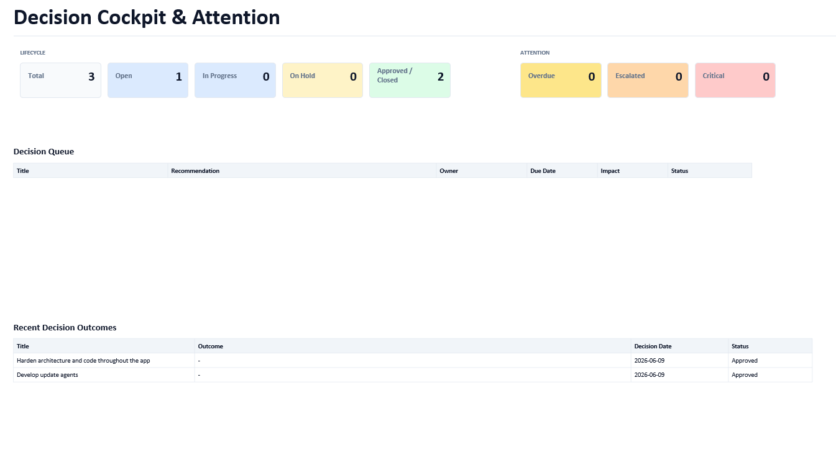
This is bad /there should be separation between Risk Cockpit & attention and Escalated Risks if the whole page is blank.
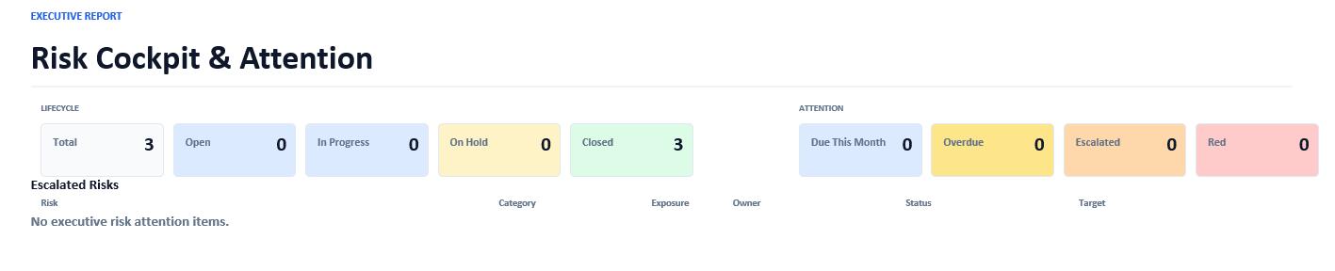

Put Workstreams and Milestones cockpits together in one page with separation (pdf and ppt).
Ok solved

In PPt I found an orphan page with only the title and the references for the gantt. This page can be removed completely.
Ok solved

In Timetracking create download of time entries in Excel so that I can create adhoc reports. You worked on it in the past review, but I do not see the corresponding button to check out. Ok solved

the new functionality. The button Excel should have the same format as in the Executive Report TAB and be placed above the + New Time Entry Button. Ok solved

In the new One page Executive Briefing
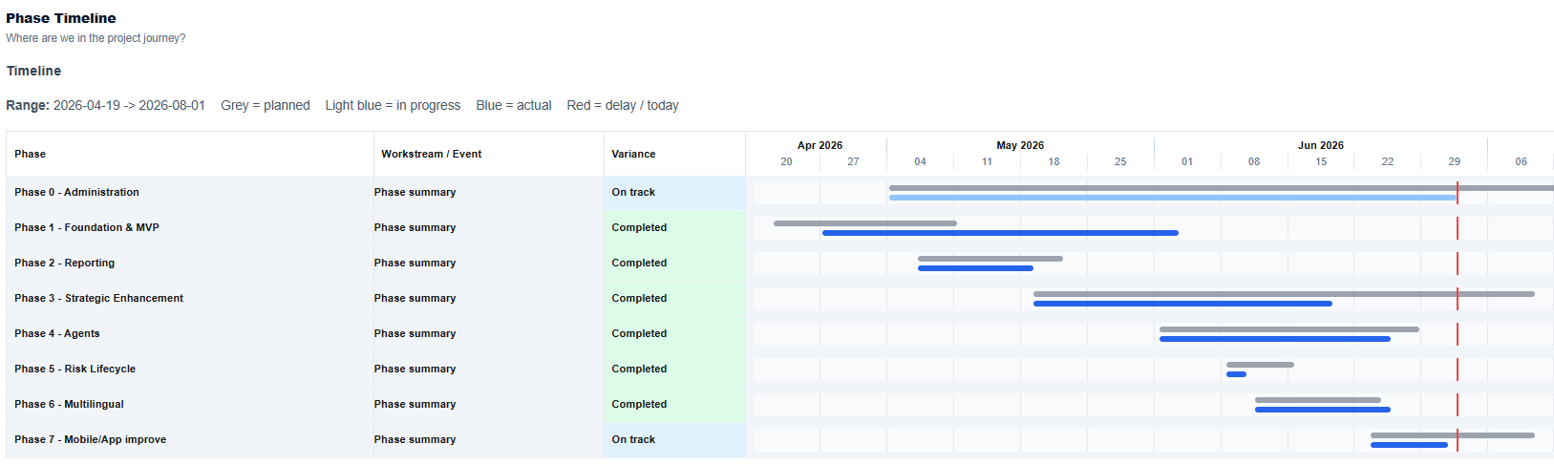
We should remove the subtitle TimeLine. Ok solved
The column Workstream worries me because When we show Phases only it shows always Phase summary (I would leave this blank). Ok solved

We have now Phases only and this works fine to collapse the workstreams, but it also makes the milestones disappear, Executive visible project level milestones should be visible. Ok solved

The Project Pulse section does not have the standard boxes of the rest of the cockpits. They occupy the whole length of the section. The boxes will be longer than the standard cockpit boxes but the same height. Nok the boxes do not have a standard length but occupy the whole length of the section.
the number is placed right of the box but aligned with the text. Ok solved I would make two rows. Ok solved The first row contains the two boxes with Completed workstreams and completed milestones. Ok solved Second row: the two boxes with closed risks, New escalations. Ok solved

Now the layout looks funny because we have two isolated very broad Executive summary and Conclusion sections.
My proposal is:
After the Phase Timeline section
Executive Summary Delivery Status Project Puls Progress since
last report
Risks Decisions Issues/Concerns Next Steps

Management Ask Conclusion

This saves us one section and we will likely be able to print everything in one page.
We should be able to include this Briefing in the PPt and Pdf reports and also create a pdf and ppt with only this overview.

